EXPERIMENT9

ImplementDielectricfreespaceboundaryconditioninElectricField and find the relative permittivity of the different medium.
Aim:
TowriteprogramforDielectric–freespaceboundaryconditioninElectricfield using SCILAB.

Softwarerequired:
- SCILABversion6.0.1

Program:

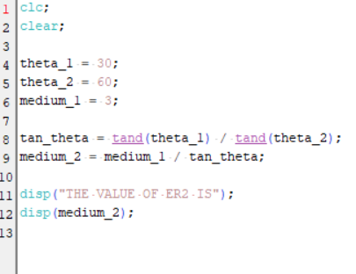

Output:

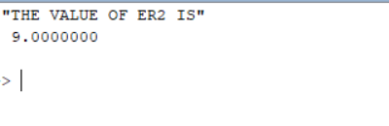

Theoreticalcalculations:
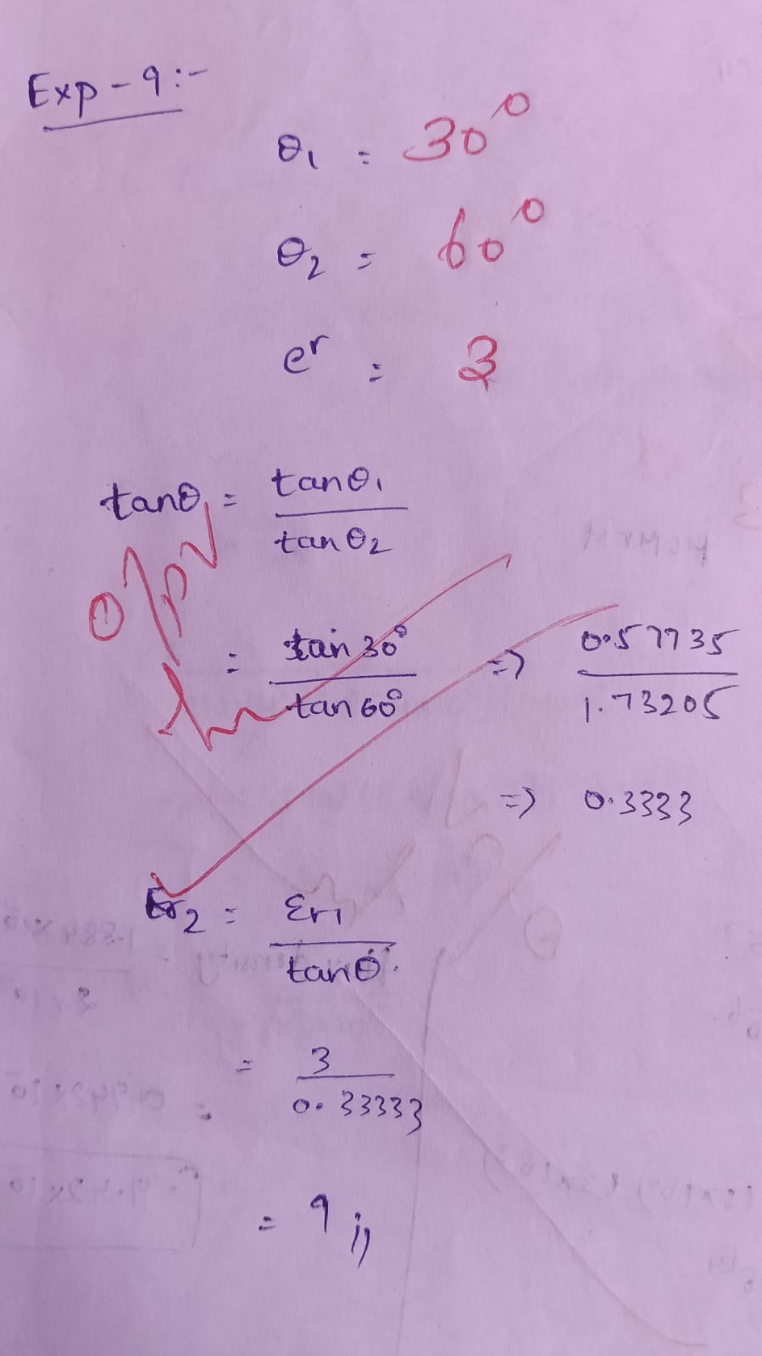

Case1:Inthiscase,thedielectricmediumhasarelativepermittivity (εr) of 2, meaning the
Dielectricreducestheelectricfieldbyhalfcomparedtothefreespace.Thisistypical for
Materialslikemicaorcertaintypesofplastics.
- FreeSpaceElectricField(E1):100V/m
- DielectricElectricField(E2):50V/m

Case2:Here,thedielectricmediumhasahigherrelativepermittivity (εr=2.5) compared to
Case1.Thisindicatesastrongerpolarizationeffectinthedielectric,asseenin materials like
Glassorwater.
- Parameters:
OEn1=200V/m (Electricfieldinfreespace).
OE2n=80V/m(Electricfieldinthedielectricmedium).

Case3:Thedielectricmediumherealsohasarelativepermittivityof
2.Thebehaviorofthe
Material suggests it couldbeanother low-polarizationdielectricmaterial, witha consistent
Reductionoftheelectricfield byhalf.
- FreeSpaceElectricField(E1n):150V/m
- DielectricElectricField(E2n):75V/m

Program:
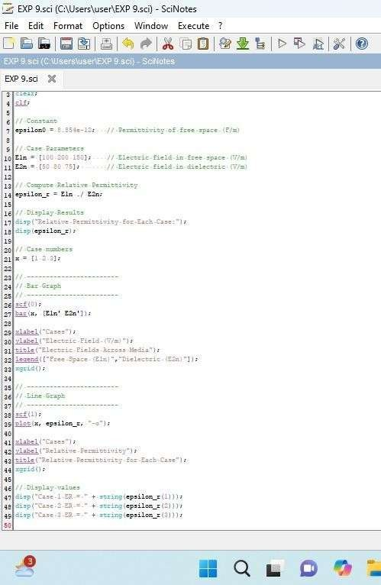

Output:

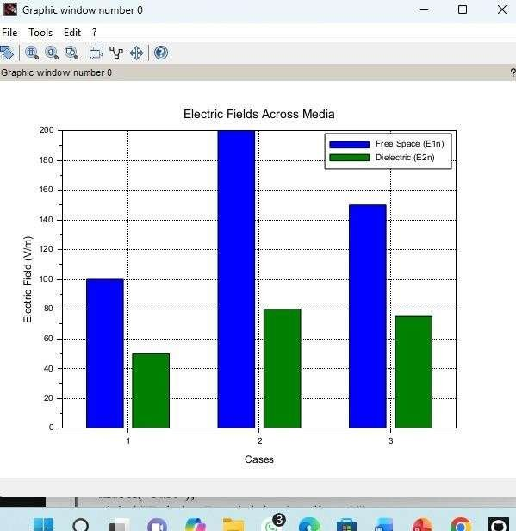

Theoreticalcalculations:

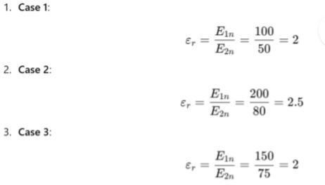

Result:
Thus the program was verifiedfor Dielectric–freespace boundaryconditionin Electric field using SCILAB was successfully.

